Association investigation for SID LR transplant operation

Existing SID 9

See table at end for assoc details.
Here we show the MTE classes, their inter-associations and any associations to the rest of the SID.

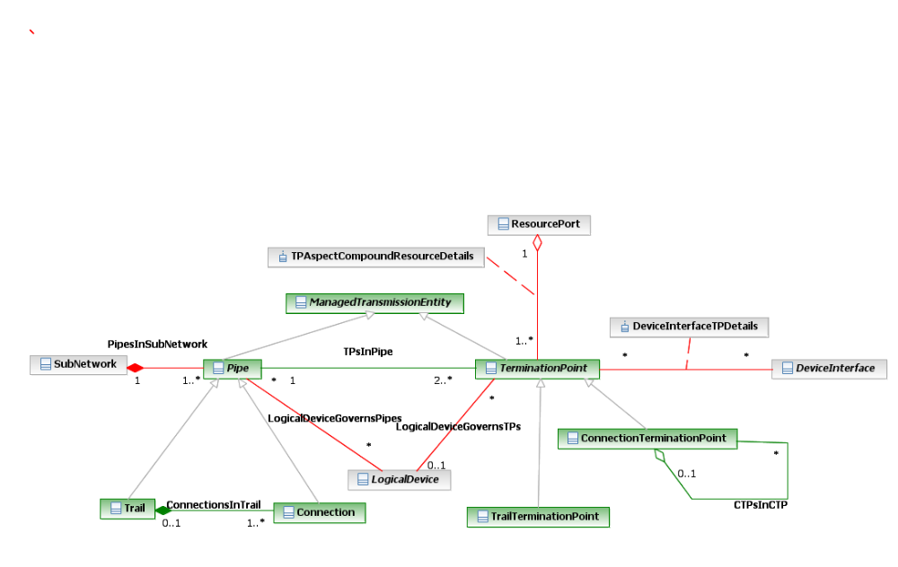
Figure 1

Existing MTNM

See table at end for details
Here we show only MTNM classes in scope to be transplanted to the SID that have associations to the rest of MTNM.

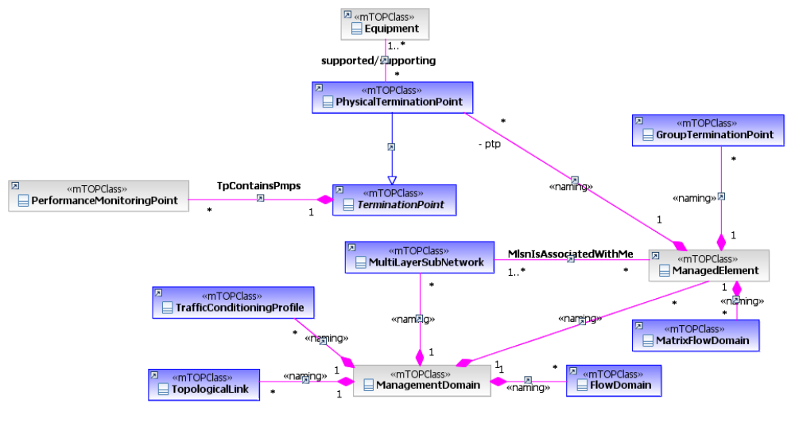
Figure 2

SID9 ++ Proposal

Old Classes remain but are deprecated.
All red associations in fig.1 have been moved to the new classes.

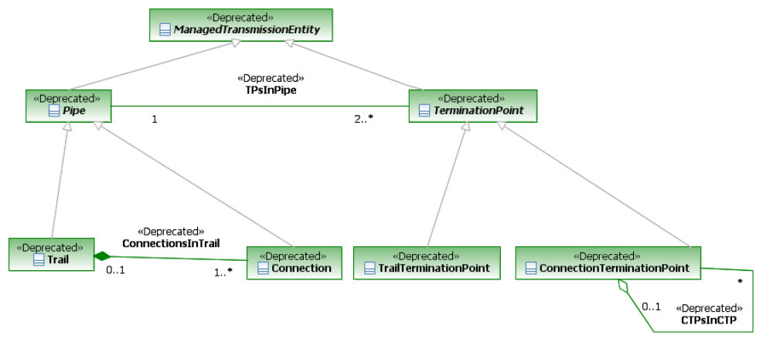
Figure 3
New merged model
Note the red SID assoc from fig.1 plus the pink MTNM assoc from fig.2
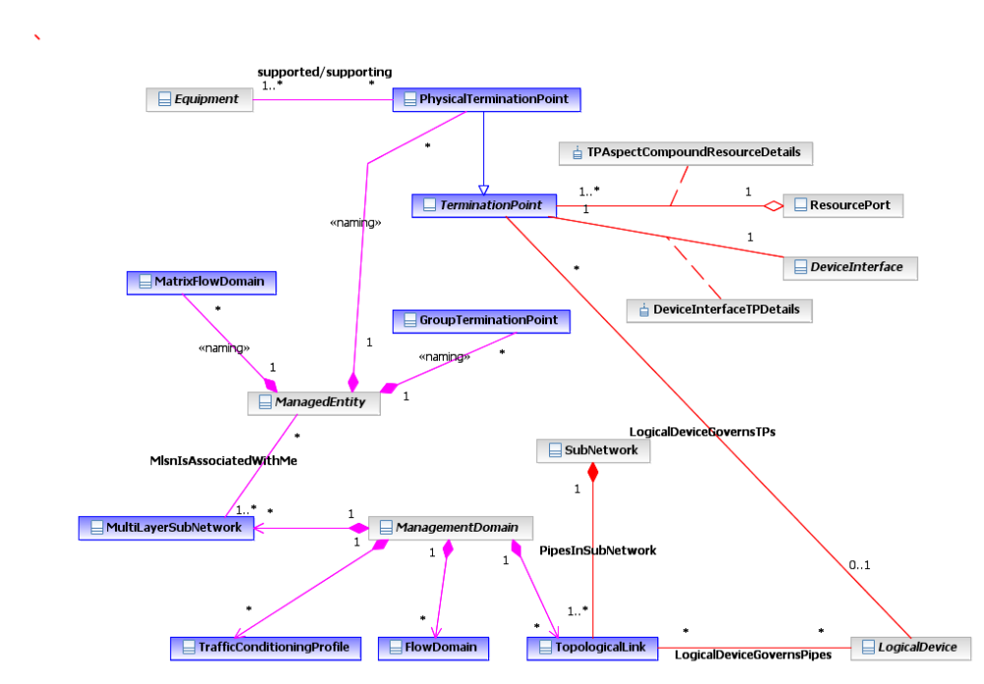
Figure 4

SID 9

Assoc | AEnd | Bend
Resource Domain::Resource ABE::LogicalResource ABE::Network ABE::PipesInSubNetwork | Subnetwork | Pipe
Resource Domain::Resource ABE::LogicalResource ABE::Logical Device ABE::LogicalDeviceGovernsPipes | LogicalDevice | Pipe
Resource Domain::Resource ABE::LogicalResource ABE::Logical Device ABE::LogicalDeviceGovernsTPs | LogicalDevice | TerminationPoint
Resource Domain::Resource ABE::LogicalResource ABE::Managed Transmission ABE::Termination Point ABE::TPAspectCompoundResourceDetails | ResourcePort | TerminationPoint
Resource Domain::Resource ABE::LogicalResource ABE::Device Interface ABE::Device Interface Association ABE::DeviceInterfaceTPDetails | DeviceInterface | TerminationPoint

MTNM

Assoc | AEnd | Bend
NetworkResourceAssurance::Data Object Classes::TpContainsPmps | PerformanceMonitoringPoint | TerminationPoint
NetworkResourceFulfillment::Data Object Classes::supported/supporting | PhysicalTerminationPoint | Equipment
NetworkResourceFulfillment::--- | TopologicalLink | ManagementDomain
NetworkResourceFulfillment::--- | TrafficConditioningProfile | ManagementDomain
NetworkResourceFulfillment::Data Object Classes::--- | ManagementDomain | MultilayerSubNetwork
NetworkResourceFulfillment::Data Object Classes::--- | ManagementDomain | ManagedElement
NetworkResourceFulfillment::--- | FlowDomain | ManagementDomain
NetworkResourceFulfillment::Data Object Classes::MlsnIsAssociatedWithMe | MultilayerSubNetwork | ManagedElement
NetworkResourceFulfillment::Data Object Classes::--- | ManagedElement | MatrixFlowDomain
NetworkResourceFulfillment::Data Object Classes::--- | ManagedElement | PhysicalTerminationPoint
NetworkResourceFulfillment::Data Object Classes::--- | ManagedElement | GroupTerminationPoint

